Becoming Human

Directions: For the questions below, surf the web to aide you in finding answers to questions that will help you understand the origins of modern humans. To speed up the research process, simply click on “Click here.” If you so desire, you may use other search engines to find the answers. MSN, Alta Vista, and Goggle tend to yield the best results. If you use a search engine other than those for the “Click here” links, you must parenthetically cite all of your sources for those answers.
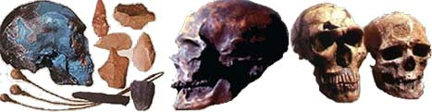

Keywords: Human Origins, Evolution, Australopithecus Afarenus, Homo Sapiens Sapiens, Homo Sapiens Neandertalenis, Out of Africa Theory + Human Origins, Human DNA, Charles Darwin

Click here to find answers to the following questions
- How closely related are we to other primates?

- Which primate is our closest living relative?

Click here to explore various web pages containing answers to these questions.
- What is the scientific name of the genus to which humans belong?

- What is the name of our species and what does it mean?
- What is the name of the first human species to migrate out of Africa and adapt to a wide variety of environments in Europe and Asia?
- Explain the Radiation Theory of human migration out of Africa.
- Explain the Parallel Theory of human migration out of Africa.
- Which species of hominids is humankind’s oldest relative? How long ago did it live? And, in what region of the world did it live?
- When did Homo Sapiens Neandertalenis live and how are they related to modern human beings?
- How far back can we trace the origins of Homo Sapiens Sapiens?

