The Japanese Internment

Directions: For the questions below, surf the web to aide you in finding answers to questions about the Japanese internment during World War II. For best results, use a variety of search engines. MSN, Alta Vista, Yahoo, and Google tend to yield the best results.

Keywords: Executive Order 9066, FDR, Manzanar, Japanese American Internment, Concentration Camps, Come See the Paradise, Prisoners of War, World War II, Nagasaki, Hiroshima, Amendments to the Constitution

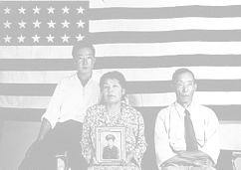
- Who was the U.S. president at the onset of World War II?

- What was so infamous about December 7, 1941?

- What was Executive Order 9066

- What does Issei mean?

- What does Nisei mean?

- In what states were the Japanese Internment Camps located?

- What camps were located in California?

- Specifically, where was Manzanar located?

- What cultural factors led the U.S. government to inter all Japanese Americans rather than all German Americans or Italian Americans?

- What was life like for the imprisoned Japanese Americans at Manzanar?

- When did the Supreme Court rule that the internment of Japanese Americans was illegal?

- Were any Japanese Americans allowed to fight for the United States during World War II?

- What ended the war with Japan and on what date did it occur?

- What laws specifically discriminated against Japanese Americans in the U.S. and California up through the 1940s?

- What other ethnic groups were imprisoned in the U.S., why, how many, and where were these concentration camps located?

- What amendment to the constitution states how someone becomes a U.S. Citizen and what does the amendment say?

