Welcome to California

Web Search

Directions: Before doing your web search, save this document into your “My Documents” folder on the school server. For the questions below, surf the web to aide you in finding answers to questions about California’s history. To speed up the research process, you do not need to answer these questions in sequential order. For best results, use a variety of search engines. MSN, Alta Vista, Ask Jeeves, Yahoo, and Google tend to yield the best results.

Keywords: California, Gold Rush of 1848, Los Angeles, California + History, 2001 Census + California, California Population, California + Spanish Exploration, California Bear Republic, California + Admission to U.S.

- When was California first explored by Spain and why was it named California?

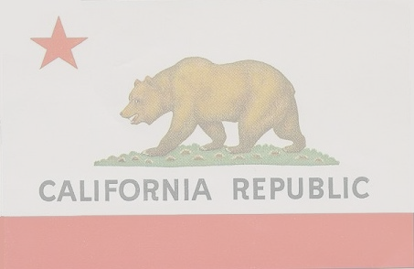
- How long had Native American tribes lived in California before the arrival of Spanish explorers?

- Specify the approximate years that California was under Spanish control.

- Indicate the years that California was a part of Mexico.

- What was the complete, original Spanish name of Los Angeles?

- How many people founded Los Angeles, what was their cultural background, and in what year was it originally settled?

- When was California an independent republic and what significant event
lead to its independence?

- What event caused scores of thousands of people to rush to California in the nineteenth century?

- On what date was California admitted to the Union and what number state did it become?

- What is the current population of California and what is its ethnic composition?

