To Kill a Mockingbird: Preparation for the Trial of Boo Radley

Directions: Gather your entire group together and plan which evidence, witnesses, and essays to use in your case for or against Boo Radley. Be sure to get one another’s e-mail and phone number, as well.

- Meet with your group and decide upon whether your team will prosecute Boo Radley on charges of first degree murder, second degree murder, or manslaughter. If you are on the defense team, you must decide if you will argue for justifiable homicide or for acquittal on any and all charges.

- As a group, choose a recorder and list all the physical evidence you can bring in to prove your case. Also, create a list of supporting testimony from the witnesses in the case (Mayella, Heck Tate, Judge Taylor, Scout, Jem, and Boo) that will help you prove your case.

- Assign who will bring in the physical evidence to help prove your case. Every member in your group must bring in at least one piece of physical evidence.

Physical Evidence
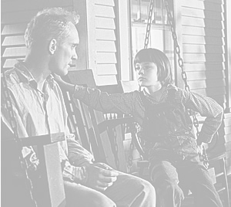
Item Person Item Person Item Person
1. 6. 11.
2. 7. 12.
3. 8. 13.
4. 9. 14.
5. 10. 15.

Testimony
Witness Page Number Witness Page Number Witness Page Number
1. 6. 11.
2. 7. 12.
3. 8. 13.
4. 9. 14.
5. 10. 15.

- On a separate piece of paper, write five questions for each witness you will question during the trial.

- On a separate piece of paper, write two questions you anticipate the opposition will ask your witnesses during the trial.

- As a team, prepare on note cards the best questions, including follow-up questions, for each witness you’ll call during the trial. Meet with your witnesses and go over testimony with them, role-playing the prosecution and defense. Anticipate the weaknesses of your case.

- In small groups of three or four, each person will read her or his essay out loud. Within the smaller groups, decide which essay is strongest. Then, meet as a larger group and read the top rated essay for each smaller to the entire group. Then, complete the “Case Presentation” guide below.

- Finally, decide which students will present your case for or against George Milton by completing the “Case Presentation” guide. Choose the person whom you believe will be the most convincing in front of a jury. It does not have to be the person who wrote the essay.

Trial Presentation Outline
The People of Alabama vs. Arthur Radley

Directions: Read each other’s essays and decide who has the best thesis, examples to support the thesis, and conclusion that clearly states why the jury should vote in your favor. Each paragraph of the essay must be from a different group member. For your case, modify one another’s writing so it creates a unified, coherent, and logical thesis and essay to present to the judge and jury.

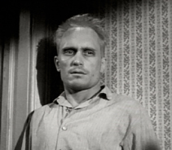
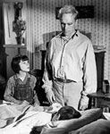

Opening Statement

I. Opening Statement (Introduction)
A. Sets the Mood
1. Statement of group thesis and how jury must vote: ___________________
___________________________________________________________
___________________________________________________________
___________________________________________________________
Person presenting closing statement:

II. Presentation of Arguments: (Body Paragraphs)
A. Supports Structure of Thesis
      - Statement that supports thesis: __________________________________
____________________________________________________________
Person reading the statement to jury:

B. Supports Structure of Thesis
      - Statement that supports thesis: __________________________________
____________________________________________________________
Person reading the statement to jury:

C. Supports Structure of Thesis
      - Statement that supports thesis: __________________________________
____________________________________________________________ Person reading the statement to jury:

III. Closing Statement: (Conclusion)
              - Closes the Mood
1. Restatement of group thesis and how jury must vote: _________________
___________________________________________________________
___________________________________________________________
___________________________________________________________
Person presenting closing statement:

