To Kill a Mockingbird
Point of View Quiz
Chapters 18, 19, 20, 21, 22, 23, and 24

Directions: Please write from the point of view of the various characters noted in each chapter below. Be sure to use the pronoun “I” when responding to each prompt or question. As usual, write in complete sentences.

- Chapter 18
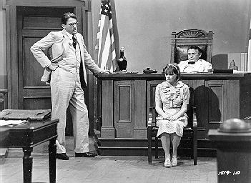
1. Imagine you are Mayella Ewell and you’re being questioned by Atticus. Explain what happened on the day Tom Robinson visited you and upset your father.

- Chapter 19
2. Imagine you are Tom Robinson’s wife who visited him in jail after his testimony. What positive testimony did he give, and what testimony hurt him?

- Chapter 20
3. Now, you’re Atticus Finch, and you’re preparing for your closing argument. List five strong statements you want to make that will convince the jury that Tom Robinson is not guilty.

- Chapter 21
4. Time to imagine you’re Scout. Explain what you meant when you thought how the jury returning was like watching “Atticus walk into the street, raise a rifle to his shoulder and pull the trigger, but watching all the time knowing that the gun was empty” (211). Also explain how the jury’s decision regarding Tom Robinson is symbolic of the simile you used.

- Chapter 22
5. Difficult as it may be, imagine you’re Bob Ewell. Explain why you are so angry with Atticus Finch.

- Chapter 23
6. So now you’re Jem Finch. What angers you so much about what happened to Atticus, and what advice did Atticus give you that helps you understand why it happened?

- Chapter 24
7. Writing from Aunt Alexandra’s point of view, what shocking news do you get from Atticus, and what does Miss Maudie say to you to help you understand why Atticus had to take Tom Robinson’s case?

