To Kill a Mockingbird
Point of View Quiz
Chapters 28, 29, 30, and 31

Directions: For each chapter, please write a response of at least one hundred words. Be sure to write from the point of view asked in the writing prompt, and use your point of view rubric to guide your response.

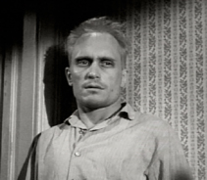
- Chapter 28
1. Imagine you are the costume Scout wore. Describe your evening in detail, and be sure to include where you went, what you saw, what happened to you.

- Chapter 29
2. Now, you are Boo Radley, describe your evening in detail. Be sure to include your feelings toward everyone involved, explaining why you did what you did.
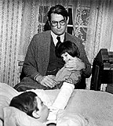

- Chapter 30
3. Time to get creative again. You are the Finches front porch. Who walked on you? What conversations took place? What metaphor was used? What lessons were learned?
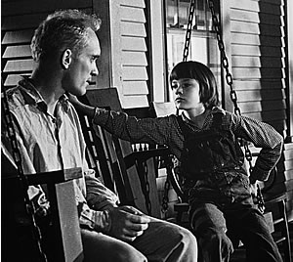

- Chapter 31
4. Writing from Scout’s point of view, what do you now understand about Boo that you never did before, what gave you this insight, and what for what are you thankful?

