To Kill a Mockingbird
Rising Action Quiz
Chapters 9, 10, and 11

Directions: Please restate the question as part of your answer and make sure you answer all parts of the question or only half credit will be received. You must write in complete sentences.

- Chapter 9
- Atticus is to defend a member of Calpurnia’s church. What is that person’s name and explain why Atticus takes a case that is causing so much dissension in the neighborhood.

- What is “Maycomb’s usual disease” that Atticus hopes Scout and Jem will not contract?

- Proponents of behavior modification believe that a way to reduce an undesired behavior is to ignore it. Identify an undesired behavior in Scout that Atticus sought to extinguish through ignoring it?

- Chapter 10
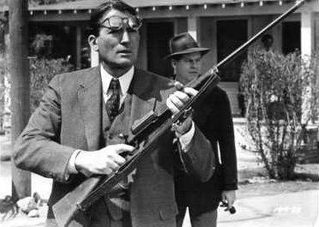
- Who does Calpurnia warn about the rabid dog and what did Scout, Jem, and Dill learn because of her actions?

- How are Atticus’s actions regarding the dog symbolic of his decision to take Tom Robinson’s case?

- Why do you think Calpurnia is supposed to go to the back door at the Radley place and what does this reveal about custom in Maycomb?

- Chapter 11
  - Why do Scout and Jem hate Mrs. Dubose at first?

  - What things does Atticus require Jem to do to make amends for his rage toward Mrs. Dubose?

  - What does Atticus say is the one thing that “doesn’t abide by majority rule” and what does this reveal about him taking Tom Robinson’s case?

10. What does Mrs. Dubose give Jem before she dies and what lesson does Jem learn from this?

