Freshman Research Paper
I-Search Essay


Writing Situation: One of the most entertaining, yet most productive ways to write is by doing an I-Search essay. By way of increased freedom over content and subject matter, the I-Search lets the author choose how to present and write her or his paper. It usually involves first-hand research of whatever topic the author--you--chooses. Also, the I-Search lets you write in the first-person. For example, if you wanted to research scuba diving, you would conduct first-hand research and present your findings in a formal manner; yet, it would be fun because the essay allows you to tell a story. The fundamental goal of the I-Search is to get the writer to build on the more basic elements of good writing: grammar, presentation, story-telling, and research; however, it does not dwell on the formalities that many other forms of writing, such as the traditional research paper, do.

Directions for Writing: Choose a topic that you don't know very much about but arouses your curiosity and research it on the Internet according to the guidelines below. Your essay must be written from the first person point of view, exploring what you already know or interests you about the subject and will be guided by a controlling question at the end of the introduction. Your body paragraphs will explore the methods you used to do your research and what you learned during the process. Lastly, you will write a conclusion that reflects about what you now know about searching for information that you didn’t know before, and how this knowledge will affect the way you think or act in the future about researching a topic.
Basic Requirements
- Select a topic: You’ll need to do some brainstorming and web research to help you choose a topic, but don't freak out. Choose a topic early on and stick with it.
- Write a specific research question. Of course, you'll need to revise it and narrow this question further as you do your research.
- Use Cornell Notes to keep track of your own research process. Once your narrowed research begins, you’ll need to keep track of your own research process. That means to take Cornell Notes on all the false leads you may follow, as well as on the more helpful searches. In addition, you’ll need to write about this information in one of the sections of your I-Search essay.
- Find at least six useful sources for your essay. Your sources will include the Internet, an interview, and a print source. You will need to present these sources in MLA format.
- Organize your paper into four sections:
  - The Search Question (Introduction ) ¾ to 1 Page
  - The Search Process (Body Paragraphs) 1 ½ to 2 Pages
  - What I Learned (Body Paragraphs) 1 ½ to 2 ¼ Pages
  - What This Means to Me (Conclusion) ½ to 1 Page
- The length of the essay must be at least four-and-a-quarter pages and no longer than six-and-a-quarter pages. If it is shorter or longer than these parameters, it will only receive half-credit.
- Class presentation: You will have to do a five to seven minute, multi-media class presentation of your essay. Two minutes of your presentation will be allowed for questions and answers.
Step 1: Pick a Topic. Choose something that you want to know more about. Make sure it’s something that matters to you, whether it's a serious topic or a topic that just amuses you. Some students may use it as a way to learn about things they've always been curious about. For instance, have you ever wondered about how eggs are graded or how a person becomes a foley artist (that’s the person who uses pots and pans and everything in between to make the booms, bangs, and whizzes you hear in movies)? Maybe you’d like to research how to buy a house or how Big Foot or Chupacabre legends got started. The only limit is your imagination.
Brainstorming Your Topic: To help you get a handle on what topic you’ll choose, do a brainstorm by putting “I-Search Essay” in the center. Then, quickly brainstorm several subjects you’ve always been curious about. Next, around those topics, brainstorm related subjects or topics, and keep doing this for every topic until you’ve exhausted the squishy grey-matter inside your cranium. Finally, choose one of those topics in your brainstorm to be the basis for your I-Search essay.
Step 2: Write Your Research Question. You can do this before you do any research. What do you want to know about your subject? Here are some examples of research questions:
- How does a person become a licensed pet therapist?
- What would my life be like if I joined the Peace Corps?
- Do animals have ESP?
- What's the best laptop computer on the market for me?
- How does dream interpretation work?
- What are the "must-see's" in Mexico City for my upcoming trip?
- What sort of plans and arrangements should I make for the first time I go snowboarding in New Zealand?
- What's the best university for a degree in parapsychology?
- What were the factors leading up to Japanese Americans being put in concentration camps in the United States during World War II?
- What's involved in that surgery that corrects people's vision?
- How do you make cheddar cheese as opposed to Gouda cheese?
- What are the common beliefs involving reincarnation?
Step Three: Conducting Your Research. As you're researching your topic, take Cornell Notes as you visit various sites. You’ll need to rely upon your notes when you write the search process part of your essay. Print a page as you go to sites that you suspect you'll want to use, making sure that you have from each site the information that you'll need to write a Works Cited page.

You're going to have to be skeptical. The cool and dangerous thing about the Internet is that anybody can publish anything at all on it. Consequently, you have to evaluate your sources. How you define your research question will have a lot to do with how you evaluate your sources. What's your purpose in writing? Is it to inform or is it to persuade? Whichever purpose you settle on, you'll need to keep in mind that your audience, to the best of your knowledge, is neutral, meaning that they do not necessarily agree with you. You'll have to convince them that you are an intelligent, balanced, articulate spokesperson and writer.

Step Four: Formal Outline. Before writing your rough draft, create a formal outline of your essay by relying upon your Cornell Notes and other source materials to create it.

- Introduction
  - The Search Question (Set the Mood)
    - Reflect upon the topic of your I-Search
    - Explain what you already know or wonder about the topic
    - Explain why you chose the topic
    - Write your search question (thesis statement)

- Body Paragraphs*
  - The Search Process (Initial Steps)
    - Statement about the value of the web sites you went to and/or other sources you used, including your interview
    - Example about the information you found (and the value of other links or references)
    - Explanation about the usefulness the information was (did it support your search question?)
  - The Search Process (Subsequent Steps)
    - Statement about the value of the web sites you went to and/or other sources you used, including your interview
    - Example about the information you found (and the value of other links or references)
    - Explanation about the usefulness the information was (did it support your search question?)
  - What I Learned
    - Statement about what you learned
    - Example directly citing information from which you learned
    - Explanation about the example clearly showing what you learned
  - What I Learned
    - Statement about what you learned
    - Example directly citing information from which you learned
    - Explanation about the example clearly showing what you learned

*Body paragraph length will vary according to depth of research. Minimum of four body paragraphs is required.

- Conclusion
  - What It Means to Me
    - Statement about what you now know about searching for information that you didn’t know before. (Do not write about the topic)
    - Reflect on how this knowledge will affect the way you think or act in the future about researching a topic.
    - Explain what kind of skills you have developed as a researcher and writer.
    - Explain what you learned about the thinking process involved in doing research, and how it felt once you made this realization.

Step Five: Rough Draft: Working from your formal outline, Cornell Notes, and other source material, write your rough draft in MLA format. Please be sure to read the “Writers Rules” and “Pointers” list in your English notebook, as well as reviewing all necessary information in “The Write Way” packet. Remember, your essay must be at least four and-a-quarter pages long and no longer than six and-a-quarter pages or it will receive only half credit. Finally, read the rubric below before writing your draft.

An “A” essay will do all or most of the following…

- Introduction contains a lead that reflects in depth about the topic for your research project, hooks your audience’s attention by describing in detail what you already know about your subject or why you are curious about it, and thoroughly explains why you chose the topic

- The search question (thesis statement) strongly controls your essay, thoroughly guides the direction of your search process, keeps the focus on what you learned, and appears as the last sentence of your introduction

- Body paragraphs focus in depth on the search process and clearly explains in at least five sentences the value of the web sites you visited and/or the other sources you used, including your interview

- Body paragraphs focuses in depth on what you learned from your research and clearly explains in at least five sentences the examples you cited in support of your search question
- Body paragraphs contain at least six relevant citations from at least four different teacher approved sources including the Internet, a print source, an interview and is thoroughly explained in relation to the search process demonstrating what you learned in support of the search question

- Written in MLA format, uses parenthetical citations, and is between four and-a-quarter and six and-a-quarter pages long with paragraphs of at least eleven sentences or more whereby the writer varies the paragraph structure by providing in-depth, insightful, and motivated writing

- Transition words or phrases smoothly connect sentences and or paragraphs

- Conclusion states what you discovered about searching for information, and reflects on how this knowledge affects the way you now think about a researching a topic

- Conclusion clearly explains the type of skills you developed as a writer-researcher, explains what you learned about the thinking process involved in research, and clearly explains how you felt once you made this realization

- Relatively free of pointers, spelling, grammatical, and mechanical errors
Step Six: Peer Evaluation and Parent Edit. Using the rubric below, evaluate your writing partner’s I-Search essay. For this scale, a score of zero is lowest and a score of four is highest. After each criteria is evaluated, write in the margins a brief comment stating what why that score was earned. Please be honest and conservative in evaluating the essay.

- Introduction contains a lead that reflects in depth about the topic for your research project, hooks your audience’s attention by describing in detail what you already know about your subject or why you are curious about it, and thoroughly explains why you chose the topic 0 1 2 3 4 =
- The search question (thesis statement) strongly controls your essay, thoroughly guides the direction of your search process, keeps the focus on what you learned, and appears as the last sentence of your introduction 0 1 2 3 4 =
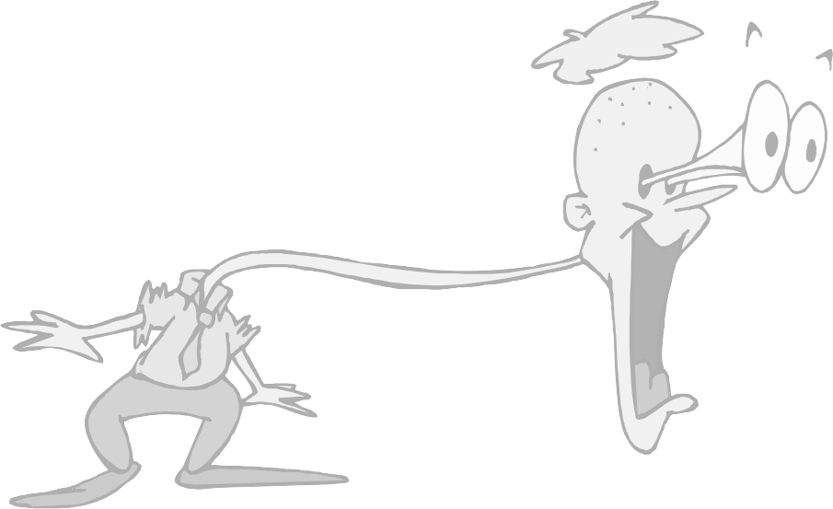
- Body paragraphs focus in depth on the search process and clearly explains in at least five sentences the value of the web sites you visited and/or the other sources you used, including your interview 0 1 2 3 4
0 1 2 3 4 =
- Body paragraphs focuses in depth on what you learned from your research and clearly explains in at least five sentences the examples you cited in support of your search question
0 1 2 3 4 =
- Body paragraphs contain at least six relevant citations from at least four different teacher approved sources including the Internet, a print source, an interview and is thoroughly explained in relation to the search process demonstrating what you learned in support of the search question 0 1 2 3 4
0 1 2 3 4 =
- Written in MLA format, uses parenthetical citations, and is between four and-a-quarter and six and-a-quarter pages long with paragraphs of at least eleven sentences or more whereby the writer varies the paragraph structure by providing in-depth, insightful, and motivated writing
0 1 2 3 4 =
- Transition words or phrases smoothly connect sentences and or paragraphs
0 1 2 3 4 =
- Conclusion states what you discovered about searching for information, and reflects on how this knowledge affects the way you now think about a researching a topic 0 1 2 3 4 =
- Conclusion clearly explains the type of skills you developed as a writer-researcher, explains what you learned about the thinking process involved in research, and clearly explains how you felt once you made this realization 0 1 2 3 4 =

- Relatively free of pointers, spelling, grammatical, and mechanical errors 0 1 2 3 4 =

Add Scores and Total =

Divide Total by 10 =

Part Seven: Revised Draft, Mini-Conference and (Final Draft): Now that you’ve received your rubric score, revise your draft according to the rubric. Then, we will hold a mini-conference to determine additional revisions that need to be made. After that revision, write your final draft and gloss the changes by highlighting them in each paragraph. Depending on the changes you made, you may receive a higher grade on this essay. Oh, and don’t forget to read the “Writers Rules,” “Pointers,” and “The Write Way” packet before doing your final draft.

