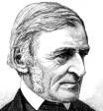
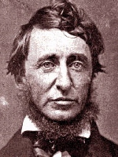
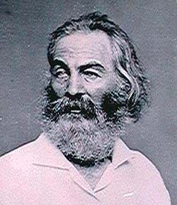

Transcendental Essay
Beginning Your Essay

Step 1: Prewriting, Establishing Examples. On this sheet or separate piece of paper, complete or create the following four column chart (leaving at least ten spaces for each entry. This may take up the front and back of a few pages of paper). In this chart, complete it by finding directly cited examples that clearly exemplify the transcendental philosophy from Emerson’s, Thoreau’s, Whitman’s writings, as well as from scenes in Dead Poet Society.

In each column, write down directly cited examples of at least two full sentences or verses that will support a tentative thesis on the transcendentalist philosophy. Be sure to use parenthetical citation format when citing your examples, complete with quotation marks, attribution, parenthesis, author’s name, page number, and correct punctuation.

You must have a minimum of fifteen examples and at least three from each source.

Emerson | Thoreau | Whitman | Dead Poets Society
1.
2.
3.
4.
5.
Emerson | Thoreau | Whitman | Dead Poets Society
6.
7.
8.
9.
10.
11.
12.
13.

