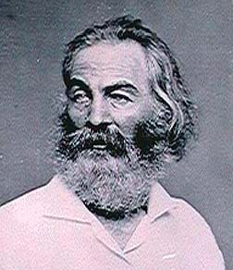
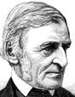
Transcendentalism
Quiz
Emerson, Thoreau, and Whitman

Directions: On your own notebook paper, please answer each question thoroughly. Be sure to restate the question as part of your answer. Since some questions have more than one part, make sure you answer what is asked or only partial credit will be received. You must write in complete sentences.

- Describe three basic beliefs of transcendentalist writers?

- What is an aphorism?
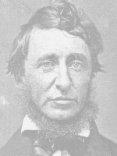
- What is one common criticism of transcendentalist philosophy?

- Writing from a transcendentalist perspective, what did Emerson mean by “a foolish consistency is the hobgoblin of little minds, adored by little statesmen, and philosophers and divines?”

- Writing from a transcendentalist perspective, what did Emerson mean when he pondered, “To be great is to be misunderstood.” Also, name two of the people he named that were misunderstood and briefly explain, in transcendentalist terms, why they were misunderstood.

- What are two essential beliefs of Henry David Thoreau’s essay “Civil Disobedience,” and what two great leaders used his philosophy to change the world in which they lived?

- From a transcendentalist point of view, why did Thoreau go to Walden Pond to live, and what were his transcendentalist reasons for leaving?

- What is free verse, and who is considered one of America’s great writers of this genre?

- In Walt Whitman’s “Song of Myself,” what does the grass symbolize or represent in this poem?

10. Explain the transcendentalist belief that best applies to your life?

