Timed Essay for “The Fall of the House of Usher.”

Writing Situation: The American poet and writer Edgar Allen Poe is best known for his short stories and poetry that deal with macabre elements of life and human nature. Such classic tales as “The Fall of the House of Usher,” “The Tell Tale Heart,” “The Cask of Amontillado,” and “The Raven” all explore the inherent duality of the human character and the potential darkness of the soul that constantly struggles for expression in life. To convey these struggles, Poe often utilizes symbolism to explore the darker nature of the human psyche.

Directions for Writing: Write a multiparagraph essay by critically analyzing the Freudian, archetypal, and contextual symbols in Edgar Allen Poe’s “The Fall of the House of Usher.” In your introduction, universally reflect upon the significance of your thesis before tying it in to events in Poe’s short story. Be sure your thesis statement is the last sentence of your introduction. In each body paragraph, use at least two examples from the book as well as one non-fiction source from the Internet to prove your thesis. Finally, restate the thesis in the conclusion, reflect upon the significance of your thesis as it relates to events in “The Fall of the House of Usher” and to the audience. Be sure to end your essay with an analogy or figure of speech that brings your essay to a powerful close that appeals to a general audience.

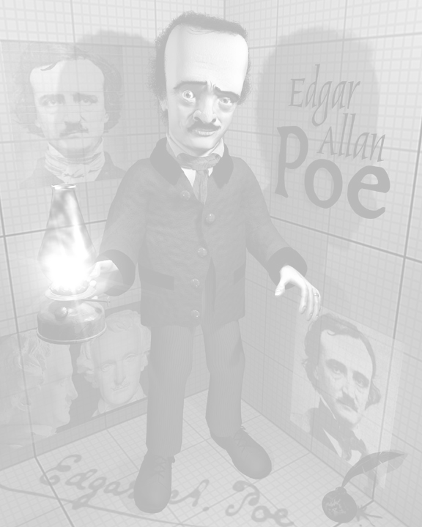
- Topic One: Write an essay using plot developments in “The Fall of the House of Usher” to clearly analyze how the Freudian, archetypal, and contextual symbols demonstrate that an incestuous relationship existed between Roderick and Madeline Usher.

- Topic Two: Write an essay using plot developments in “The Fall of the House of Usher” to clearly analyze how the Freudian, archetypal, and contextual symbols demonstrate that a incestuous relationship did not exist between Roderick and Madeline Usher and that they were simply the end result of an incestuous family.

- Topic Three: Write an essay using plot developments in “The Fall of the House of Usher” to clearly analyze how the Freudian, archetypal, and contextual symbols demonstrate that Roderick Usher was committing incest with Madeline Usher against her will.

- Topic Four: Write an essay using plot developments in “The Fall of the House of Usher” to clearly analyze how the Freudian, archetypal, and contextual symbols foreshadow the destruction of the Usher’s house and family line.

- Topic Five: Write an essay using plot developments in “The Fall of the House of Usher” by creating your own topic. Your topic must analyze the Freudian, archetypal, and contextual symbols in the story and apply them to a clear subject on which to write. If you decide to create your own topic, you must first receive teacher approval before beginning to write.
Rubric Evaluation for “The Fall of the House of Usher” Essay

Peer Evaluation and Written Comments. Using the rubric below, evaluate your writing partner’s “The Fall of the House of Usher” essay. For this scale, a score of zero is lowest and a score of four is highest. After each criterion is evaluated, write in the margins of the rough draft a brief comment stating why that score was earned. Please be honest and conservative in evaluating the essay.

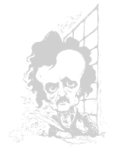
Introduction
- Introduction contains a universal lead that hooks your audience’s attention and reflects in depth about the topic you’ve chosen to write about 0 1 2 3 4 =
- Introduction narrows its reflective lead by smoothly transitioning into the topic for your essay, then sets the context of your topic by briefly summarizing “The Fall of the House of Usher” in the context of your thesis 0 1 2 3 4 =
- The thesis statement is clear, strongly controls your essay, thoroughly guides the direction of each body paragraph, and appears as the last sentence of the introduction 0 1 2 3 4 =
Body Paragraphs
- Each body paragraph contains a strong statement (topic sentence) that is clearly based on the structure of your thesis and thoroughly controls the paragraph 0 1 2 3 4 =
- Body paragraphs analyze in depth at least six directly cited examples that clearly support the structure of your thesis, are analytically explained (not summarized) in several sentences or more, while containing at least one example of antithesis (counterpoint) 0 1 2 3 4 =
- Body paragraph contains at least six relevant Freudian, archetypal, and contextual symbols citations that clearly support and prove the thesis 0 1 2 3 4 =
Conclusion
- Conclusion clearly restates the thesis by using different words and appears as the first sentence 0 1 2 3 4 =
- Reflects upon the dominant themes and issues addressed in the introduction and the body paragraphs 0 1 2 3 4 =
- Provides a strong final statement that uses a figure of speech to grab the audience’s attention
0 1 2 3 4 =
Throughout the Essay
- Written in MLA format, uses parenthetical citations, is between five and seven paragraphs of at least twelve sentences or more whereby the writer varies the paragraph structure by providing in- depth, analytical, and motivated writing 0 1 2 3 4 =
- Transitions and attribution smoothly connects sentences, direct citations, and or paragraphs 0 1 2 3 4 =
- Relatively free of pointers, spelling, grammatical, and mechanical errors 0 1 2 3 4 =

Add Scores and Total =
Divide Total by 12 = = =

Glossed and Final Draft. Now that you’ve received your rubric score, revise your essay according to the rubric. After that revision, write your final draft and gloss the changes by highlighting them in each paragraph. Oh, and don’t forget to read the “Writers Rules,” “Pointers,” and “The Write Way” packet before doing your final draft, which, of course, must be typed and in MLA format

