The Fall of the House of Usher Essay
Researching Examples

Prewriting: Establishing Examples. On this sheet or a separate piece of paper, complete or create the following three column chart (leaving at least ten spaces for each entry. This may take up the front and back of a few pages of paper). In this chart, complete it by directly citing examples from Poe’s “The Fall of the House of Usher” that are clearly Freudian, archetypal, or contextual symbols. If you desire, you may use another format to arrange your examples.

For whatever format you choose, each example must be at least two full sentences in length. Since we know Poe can be rather loquacious, if any example is over forty words, but only one sentence, that’ll be fine. Be sure to use parenthetical citation format when citing your examples, complete with quotation marks, attribution, parenthesis, author’s name, page number, and correct punctuation.

You must have a minimum of fifteen examples and at least three from each type of symbol

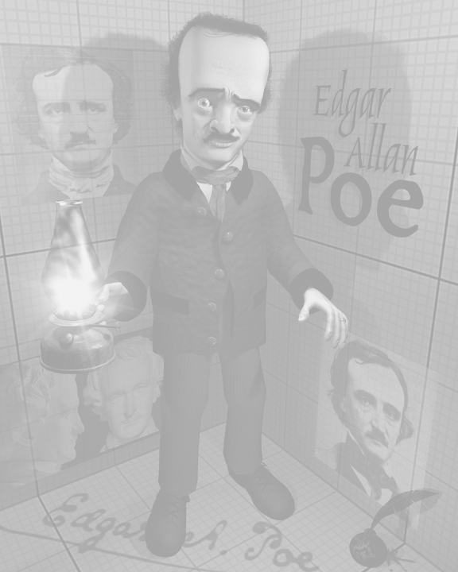  Freudian Symbols | Archetypal Symbols | Contextual Symbols
1.
2.
3.
4.
5.

