Vietnam War Web Search

Directions: After creating a Microsoft Word document and saving it into your folder, surf the web to aide you in finding answers to the following questions about the Vietnam War. Even if you think you know the answer to any one question, you must verify your answer by parenthetically citing your sources. Keep in mind that cutting and pasting your research can significantly speed up the writing process. All answers must be written in complete sentences that clearly restate the question. Please keep all your answers to no more than four sentences each, and paraphrase at least half of your responses. Lastly, consult at least two sources to verify your answer.

Keywords: Vietnam War, Vietnam War + American Involvement, Vietnam War + Fall of Saigon, Kent State, Domino Theory, Vietnam War + Number of Deaths, Vietnam War + ARVN, Vietnam War + NLF, Gulf of Tonkin, My Lai Massacre, Kent State + Vietnam War

- On what continent is Vietnam located and how far is it from Los Angeles, California to Ho Chi Minh City, Vietnam. To support your answer, copy and paste a small map of Vietnam.

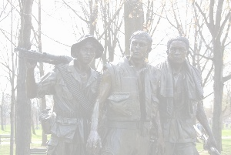
- Why did the United States get involved in Vietnam and what did Communism have to do with it?

- What was the Domino Theory and what did it have to do with the Vietnam War?

- What year did the United States involvement in the Vietnam War begin and who was the president of the United States at that time?

- What was so controversial about the Gulf of Tonkin Resolution?

- Who were the two sides that were fighting the war and what side did the United States support by sending military advisors and American troops?

- Who was Ho Chi Minh and what was his involvement in the Vietnam War?

- What was significant about the cities of Hanoi and Saigon in relation to the war?

- Which United States president significantly increased the number of United States troops participating in the Vietnam War?

- What was the My Lai Massacre and what effect did it have upon the American population’s support for the war?

- What were the NLF and the ARVN and what did they have to do with the war?

- What tragic event occurred at Kent State in 1970?

- On what date did Saigon fall, thus bringing an essential end to the Vietnam War?

- Approximately how many Vietnamese and American deaths occurred because of the war?

