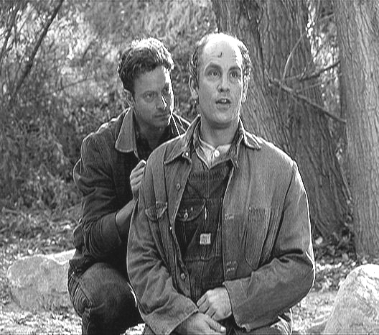
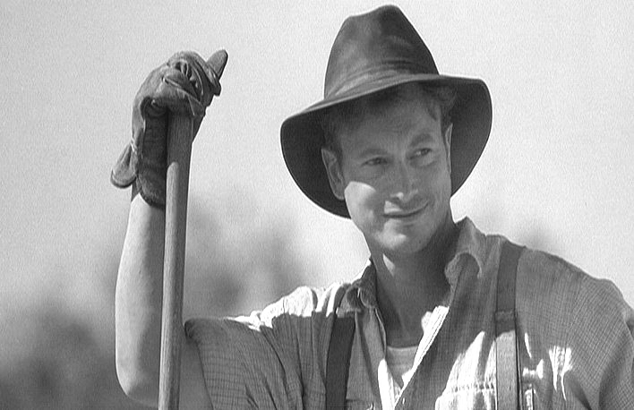
The Trial of George Milton

Researching Examples for
an Expository Essay

Prewriting: Establishing Examples. On this sheet or a separate piece of paper, complete or create the following four column chart. In this chart, complete it by directly citing examples from John Steinbeck’s Of Mice and Men that make the best case for a charge of first degree murder, second degree murder, manslaughter, or justifiable homicide. Each example from Of Mice and Men must be at least two full sentences in length. Be sure to use parenthetical citation format when citing your examples, complete with quotation marks, attribution, parenthesis, author’s name, page number, and correct punctuation.

California Criminal Code Sections

1st Degree Murder: Knowing, purposeful, premeditated and deliberate murder
(California Criminal Code 187)
2nd Degree Murder: Reckless disregard for life leading to death
(California Criminal Code 189)
Manslaughter: Causing death through negligence
(California Criminal Code 192)
Justifiable Homicide: All charges against the defendant are dropped
(California Criminal Code 195-197)

- You must have a minimum of six examples for any particular approach and a minimum total of fifteen examples for the entire brainstorm

First Degree Murder | Second Degree Murder | Manslaughter | Justifiable Homicide

