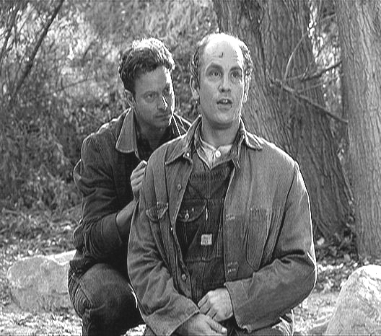
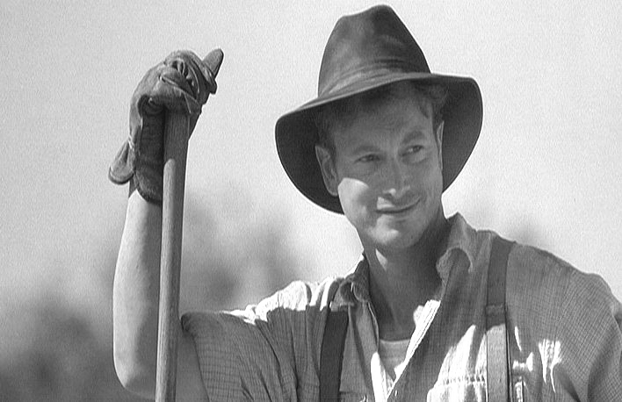
The Trial of George Milton

Prewriting the
Conclusion

Prewriting, Conclusion: On this sheet of paper, respond to the following statements that will help you outline and write your conclusion. If necessary, you may write on the back of this sheet.
- Write five or six sentences explaining why George’s actions were right or wrong.

- Write one sentence stating why George is or is not guilty for the crime with which he is charged.

- Write one sentence that makes a comparison between what happened between George and Lennie and something else everyone would understand.
- Write four or five sentences explaining why George actions were necessary or unnecessary as it relates to the average person in the United Sates.
- Write one sentence telling how a jury should vote regarding the charge for which your team is arguing.

