Reading Response Choices
John Steinbeck’s Of Mice and Men

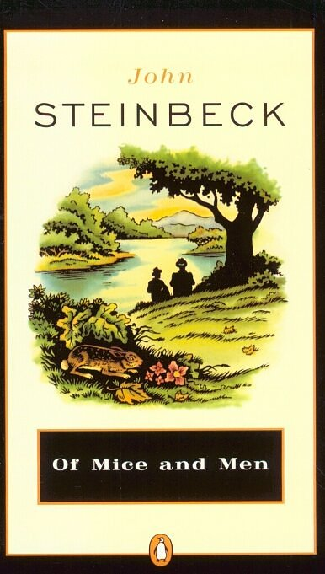
Note: Whenever you are assigned a Reading Response Choice for a particular chapter or chapters, here are your choices:

- One Pager
- Two Column Journal 10
- Four Column Journal 5
- Deep Thoughts 500
- Four Square
- Open Mind Diagram (Two Different Characters)
- Cornell Notes 4
- Blue Dot
- Headline
- Upstairs/Downstairs

