The Crucible
Rising Action Quiz
Act II

Directions: Please restate the question into a topic sentence that contains your answer. Also, be sure to write in complete sentences, and to answer all parts of the question or only partial credit will be earned. This is an open note, open book quiz for everyone, but you may not share materials.

- What does John Proctor mean when he says he mistook Elizabeth for God?

- Why does John Proctor forbid Mary to go to the courtroom?

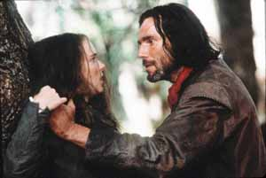
- When Reverend Hale is speaking with John Proctor, why is the critical issue whether or not Proctor believes in the existence of witches?

- What is the symbolism of using a child’s toy, the poppet, to bring down an adult woman?
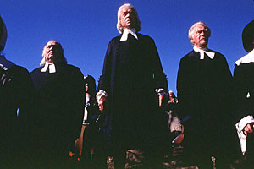
- How has John Proctor’s reluctance to tell the truth about Abigail affected the events in Act II?

- What did Reverend Hale try to do during Act II? Explain whether he succeeded in his efforts.

