Junior Research Paper
Prewriting
Choosing Your Career Path

“The Road Not Taken”
by
Robert Frost

Part I Directions: In small groups, read the poem aloud and discuss its theme or message. Then, think about the two paths you could follow upon graduating from high school, and fill in the box below the photo identifying those two paths.

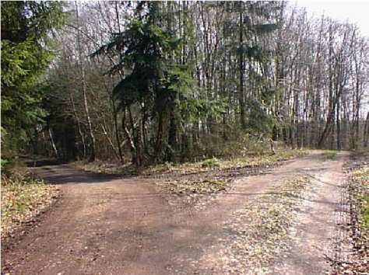
Two roads diverged in a yellow wood,
And sorry I could not travel both
And be one traveler, long I stood
And looked down one as far as I could
To where it bent in the undergrowth.
Then took the other, as just as fair,
And having perhaps the better claim,
Because it was grassy and wanted wear;
Though as for that the passing there
Had worn them really about the same.
And both that morning equally lay
In leaves no step had trodden black.
Oh, I kept the first for another day!
Yet knowing how way leads on to way,
I doubted if I should ever come back.
I shall be telling this with a sigh
Somewhere ages and ages hence:
Two roads diverged in a wood, and I--
I took the one less traveled by,
And that has made all the difference.
My Two Paths Upon Graduating
from High School

Path Number One: ________________

__________________ Path Number Two

Part II Directions: After completing the above box identifying your two career paths, complete the “Path One” and “Path Two” boxes on the back. At the bottom of each box, write in the name of each career path you could take upon completing high school.

More Directions: Working from top to bottom, draw a road (path) that would symbolize your journey from high school to working in the career. Each turn in the road must symbolize important turns you would symbolically need to take in arriving at your eventual goal. Also, include obstacles that would represent real-life obstacles that could slow you down in reaching your eventual destination: your career. Feel free to add color and other symbols to represent the nature of your journey.

Path One
Path Two

