Expository Essay for 1984
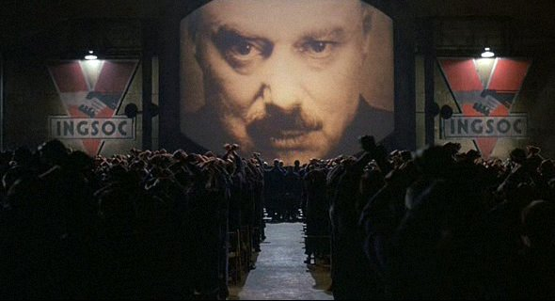
Writing Situation: Many of the predictions made by George Orwell in 1984 relating to Big Brother’s surveillance, corruption of language, and control of history have already come about to a great extent in Communist and totalitarian countries, as well as to some extent in democratic countries. In the post 9-11 world, the powers of the government to intercept mail, tap phones, and monitor people have been increased. Security agencies now have more power to keep files on law-abiding citizens and some public officials have the right to enter private homes without a warrant. In a society where government departments keep computerized information on citizens, there is a growing possibility that this information may be fed into a centralized data bank further eroding our right to privacy and freedom.

Directions for Writing: Choose one of the seven topics below to write a multiparagraph essay based on George Orwell’s 1984. In your introduction, universally reflect upon the significance of the topic before tying it in to events in 1984. Be sure your thesis statement is the last sentence of your introduction. In each body paragraph, use at least two examples from the book as well as one non-fiction source from the Internet to prove your thesis. Finally, restate the thesis in the conclusion and reflect upon the significance of your thesis as it relates to events in 1984, as well as to the audience. Be sure to end your essay with an analogy or figure of speech that brings your essay to a powerful close that appeals to a general audience.

- Topic One: Write an essay using plot developments in 1984 to clearly analyze how the world of Big Brother reflects and warns us about the growing control of corporations and government over citizens’ lives.

- Topic Two: Write an essay using plot developments in 1984 to clearly analyze how foreshadowing, irony, and symbols predict and represent Winston Smith’s fate.


- Topic Three: Write an essay using plot developments in 1984 to clearly analyze how the policies of the Bush Administration parallel those of Big Brother and the effect it has upon civil liberties in the United States.

- Topic Four: Write an essay using plot developments in 1984 to clearly analyze how doublethink and newspeak have crept into modern American English, as well as how the idea of thoughtcrime and the thoughtpolice is becoming a reality in modern life.

- Topic Five: Write an essay using plot developments in 1984 to clearly analyze how the novel is a satire of the Soviet Union and Nazi Germany--and to a lesser extent socialist England--in the years prior to and immediately following World War II.

- Topic Six: Write an essay using plot developments in 1984 to clearly analyze Winston Smith’s existential struggle in a totalitarian society dominated by Big Brother, newspeak and thoughtcrime.

- Topic Seven: Write an essay using plot developments in 1984 by creating your own topic. Your topic must analyze events, themes, characterization or other literary techniques in the plot and apply them to a clear subject on which to write. If you decide to create your own topic, you must first receive teacher approval before beginning to write.
Rubric Evaluation for 1984 Essay

Peer Evaluation and Written Comments. Using the rubric below, evaluate your writing partner’s 1984 essay. For this scale, a score of zero is lowest and a score of four is highest. After each criterion is evaluated, write in the margins of the rough draft a brief comment stating why that score was earned. Please be honest and conservative in evaluating the essay.

Introduction

- Introduction contains a universal lead that hooks your audience’s attention and reflects in depth about the topic you’ve chosen to write about 0 1 2 3 4 =
- Introduction narrows its reflective lead by smoothly transitioning into the topic for your essay, then sets the context of your topic by briefly summarizing 1984 in the context of your thesis 0 1 2 3 4 =
- Thesis statement is argumentative, strongly controls your essay, thoroughly guides the direction of each body paragraph, and appears as the last sentence of the introduction 0 1 2 3 4 =

Body Paragraphs
- Each body paragraph contains a strong statement that is clearly based on the structure of your thesis and controls the paragraph in which it is written 0 1 2 3 4 =
- Each body paragraph analyzes in depth directly cited examples from George Orwell’s 1984 and one Internet or other secondary sources to clearly support the structure of your thesis by analytically explaining (not summarizing) in several sentences or more how the cited examples prove your thesis 0 1 2 3 4 =
- At least one body paragraph contains an example of antithesis that is thoroughly refuted 0 1 2 3 4 =
Conclusion
- Conclusion clearly restates the thesis by using different words and appears as the first sentence 0 1 2 3 4 =
- Reflects upon the dominant themes and issues of 1984 and its universal significance that were addressed in the introduction and the body paragraphs 0 1 2 3 4 =
- Provides a strong, original final statement that uses a figure of speech to grab the audience’s attention
0 1 2 3 4 =

Throughout the Essay
- Written in MLA format, uses parenthetical citations, is at least four ½ pages long, contains paragraphs of at least twelve sentences or more whereby the writer varies the paragraph structure by providing in-depth, analytical, motivated and on-topic writing 0 1 2 3 4 =
- Transitions and attribution smoothly connects sentences, direct citations, and or paragraphs 0 1 2 3 4 =
- Relatively free of pointers, spelling, grammatical, and mechanical errors 0 1 2 3 4 =

Add Scores and Total =
Divide Total by 12 = = =

Glossed and Final Draft. Now that you’ve received your rubric score, revise your draft according to the rubric. After that revision, write your final draft and gloss the changes by highlighting them in each paragraph. Oh, and don’t forget to read the “Writers Rules,” “Pointers,” and “The Write Way” packet before doing your final draft, which, of course, must be typed and in MLA format.

