George Orwell’s
1984
Quiz: Chapters 1 through 5
Part I of the Novel

Directions: On your own notebook paper, please answer each question thoroughly. For this quiz, you may use the book and your reading responses, but you may not share your book or reading responses with anyone else. Be sure to restate the question as part of your answer. Since some questions have more than one part, make sure you answer what is asked or only partial credit will be received. You must write in complete sentences.

Chapter 1
- What is the caption on the poster in Winston’s Building?
- What are the Party’s three slogans, and how is each ironic?
- What is the purpose of the Two Minutes Hate, and how is it an example of wartime propaganda?
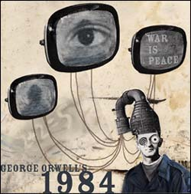
Chapter 2
- What game are the Parsons’ children playing, and how does it satirize World War II Germany?

- Winston addresses his journal to whom or what. Also, how does he define a “Thoughtcrime”?

- What does the speaker in the dream tell Winston?
Chapter 3
- What does Winston believe happened to his parents?
- With whom is Oceania at war, and, from a satirical point of view, how does it apply to the foreign policy of the United States since World War I to the current day?

- What three statements comprise the Party slogan?
Chapters 4 and 5
- What is Syme’s current project at the Records Department?
- What does Syme predict will have occurred by 2050, and what connections can to you make to modern English in 2009?

- Who does Winston believe is following him?

