George Orwell’s
1984
Quiz: Chapters 6 through 10 (Part II)

Directions: On your own notebook paper, please answer each question thoroughly. For this quiz, you may use the book and your reading responses, but you may not share your book or reading responses with anyone else. Be sure to restate the question as part of your answer. Since some questions have more than one part, make sure you answer what is asked or only partial credit will be received. You must write in complete sentences.

Chapter 6 (Part II)
1. How does O’Brien turn Winston into his accomplice, and what is O’Brien willing to lend Winston?
2. What is the one thing of which Winston is now certain, and what feeling does Winston experience as he talks with O’Brien?

Chapter 7 (Part II)
3. What does Winston believe the proles have retained, but Party members have lost?
4. After stealing his sister’s chocolate ration and running away, upon returning to his house what did Winston find?
5. In Winston’s mind, what would prove he had betrayed Julia, and according to Julia what is the one thing the Party cannot do?

Chapter 8 (Part II)
6. What privilege is reserved for Party members, and to whom do Winton and O’Brien toast?
7. According to O’Brien, what is the most Winston will ever know about the Brotherhood, and what is Winston prepared to do for it?
8. What’s in the book O’Brien plans to send to Winston, and where do they plan to meet again?
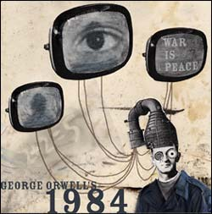
Chapter 9 (Part II)
9. With what power (enemy) is Oceania now at war?
10. What are Goldstein’s three classes of people throughout history?
11. What does Goldstein’s book claim is the primary aim of modern warfare?
12. What is the definition of Doublethink?

Chapter 10 (Part II)
13. According to Winston, what kind of world would the proles create?
14. What voice do Winston and Julia hear in the room and from where is it coming?
15. What does Winston realize as he looks at Charrington?

