CJUHSD-LOHS-Quarterly ASSESSMENT in English Proficiency
Level IV

Emphasis- Critical Analysis

Directions: Critically read the passage on the back of this page in preparation of writing a multi-paragraph essay. Use the writing process to help you organize your critical thoughts and point of analysis. Write an essay based on the following prompt:

Prompt: After reading and reflecting upon the comments by Nazi officer Hermann Goering during the Nuremberg trials after World War II, write a multi-paragraph essay exploring the significance of his observations by relating them to events in that war and to what degree they apply to our world today.

Rubric: Your essay will be evaluated according to the criteria established by the Subject A Examination rubric. Consideration is given for reading and writing accomplished in a single class period, as opposed to the benefits associated with multiple edits and revisions.

6 A 6 paper commands attention because of its insightful development and mature style. It presents a cogent response to the text, elaborating that response with well-chosen examples and persuasive reasoning. The 6 paper shows that its writer can usually choose words aptly, use sophisticated sentences effectively, and observe the conventions of writing English.

5 A 5 paper is clearly competent. It presents a thoughtful response to the text, elaborating that response with appropriate examples and sensible reasoning. A 5 paper typically has a less fluent and complex style than a 6, but does show that its writer usually choose words accurately, vary sentences effectively, and observe the conventions the conventions of writing English.

4 A 4 paper is satisfactory, sometimes marginally so. It presents an adequate response to the text, elaborating that response with sufficient examples and reasoning. Just as these examples and this reasoning will ordinarily be less developed than those in 5 papers, so will the 4 paper’s style be less effective. Nevertheless, a 4 paper shows that its writer can usually choose words of sufficient precision, control sentences of reasonable variety, and observe the conventions of writing English.

3 A 3 paper in unsatisfactory in one or more of the following ways. It may respond to the text illogically; it may lack coherent structure or elaborating with examples; it may reflect an incomplete understanding of the text or the topic. Its prose is usually characterized by at least one of the following: frequently imprecise word choice; little sentence variety; occasional major errors in grammar and usage, or frequent minor errors.

2 A 2 paper shows serious weakness, ordinarily of several kinds. It frequently presents a simplistic, inappropriate, or incoherent response to the text, one that may suggest some significant misunderstanding of the text or the topic. Its prose is usually characterized by at least one of the following: simplistic or inaccurate word choices; monotonous or fragmented sentence structure; many repeated errors in grammar, and usage.

- A 1 paper suggests serve difficulties in reading and writing conventional English. It may disregard the topic’s demands, or it may lack any appropriate pattern of structure or development. It may be inappropriate brief. It often has a pervasive pattern of errors in word choice, sentence structure, grammar, and usage.

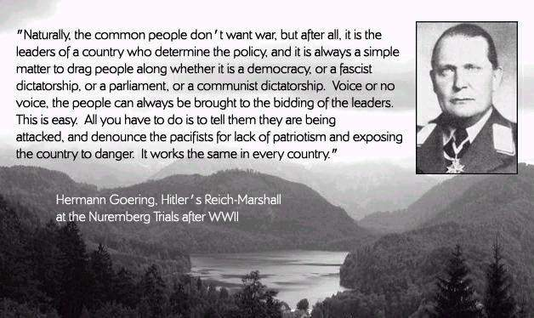

You may use the space below to plan any of your writing

