
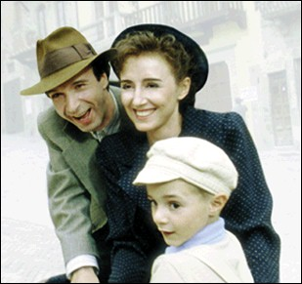
Essay on Existentialism

Researching Examples

Prewriting: Establishing Examples. On this sheet or a separate piece of paper, complete or create the following two column chart (leaving at least ten spaces for each entry. This may take up the front and back of a few pages of paper). In this chart, complete it by directly citing examples from Albert Camus’ “The Guest” and Robert Benigni's La Vita é Bella that represent at least three of the six common themes of existentialism.

Each example from “The Guest” must be at least two full sentences in length. Since we do not have the script for La Vita é Bella, the scenes you paraphrase must be at least two sentences long, as well. You may also want to check out the DVD so you can directly cite the dialogue from the movie. For “The Guest,” be sure to use parenthetical citation format when citing your examples, complete with quotation marks, attribution, parenthesis, author’s name, page number, and correct punctuation. As for La Vita é Bella, use clear attribution to indicate you’re citing the movie.

- You must have a minimum of eight existential examples for each story

“The Guest” | Existential Theme | “La Vita é Bella” | Existential Theme
1.
2.
3.

“The Guest” | Existential Theme | “La Vita é Bella” | Existential Theme
4.
5.
6.
7.
8.
9.
10.

