Macbeth: Semester 1 Final
Creating a Study Guide

Directions: During the final, you will be able to use one page of notes (front and back). If you have detailed notes for all* the topics below, you may use those notes on the test. After the study guide notes are completed, you should study and quiz yourself for a minimum of two hours (as you should for any test). Good luck and study hard! The final is worth ten percent of your final grade.

- Identify the difference between a simile, metaphor, personification, oxymoron, and irony by examining verses from the play

- Know the definition of iambic pentameter, couplet, blank verse, and soliloquy while being able to identify them from verses in the play

- Create a venn diagram exploring the similarities and differences between Shakespeare’s play and Roman Polanski’s movie
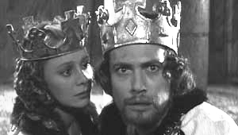
- Know the methods of characterization (flat, round, dynamic, and static) for the major characters in the play

- Create the dramatic structure for the play and identify the key scenes for each component

- Know the definition of foreshadowing and be able to identify specific events that characters or events in the play foreshadow

- Identify the subject, predicate, simple predicate, prepositional phrase, and direct object from verses in the play

- Identify examples of internal and external conflict, including character vs. character, character vs. nature, and character vs. society

- Write from the point of view of Macbeth’s crown by providing insight to the major events you have witnessed in Macbeth’s presence

- Use the editor’s guide from the Write Way packet to edit a sample passage from a student’s Macbeth essay

- Know the standard spelling, phonetic spelling, part of speech, definition, and etymology for the following words:

