Middle Eastern Culture and Literature
Quiz

Directions: On your own notebook paper, please answer each question thoroughly. For this quiz, you may use the book and your reading responses, but you may not share your book or reading responses with anyone else. Be sure to restate the question as part of your answer. Since some questions have more than one part, make sure you answer what is asked or only partial credit will be received. You must write in complete sentences.

1. Under the banner of Islam, name at least six cultural achievements that were achieved.
2. In which Arabian city was Islam founded, who was its founder, and what is the name of its holiest book?
3. By the year 1200, what was the geographical range of the Islamic empire?
4. Who were the people that are considered to be the first settlers of modern day Iran, in what year did they settle the region, and what does the name Persia or Iran mean?
5. Around the year 600 B.C., which religious prophet founded a religion that would influence Persian culture for the next 1200 years?
6. In 331 B.C. who conquered the Persian Empire?
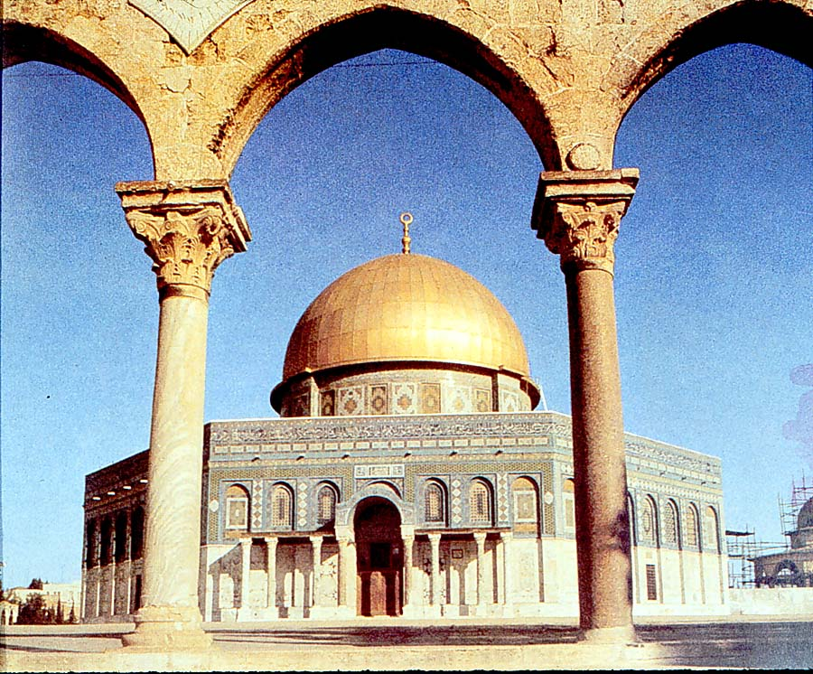
7. According to Arabic tradition, from whom do Arabic people believe they descended and with whom do they share their heritage?
8. According to tradition, who visited the prophet Muhammad and revealed to him God’s will?
9. What does the translation of the word “Islam” mean in English, and in what year did most of Arabia swear its allegiance to Islam?
10. In what year did the Persians take control of Baghdad, and what story tells the adventures of a sailor named Sindbad?
11. What rights were granted to women under Islam?
12. What is the name of one of the most splendid mosques located in Spain, and in which city is it located?
13. In about what year was Islam’s holiest book, the Koran, written?
14. From which word in Arabic does the English banking word “check” derive?
15. From which culture does the U.S. Post Office get its slogan?
16. Name five words beginning with different letters in English that derive from Arabic.
17. In about what year does tradition hold that the prophet Muhammad receive his first visit from the Angel Gabriel?
18. What does the word Koran mean, and what are followers of Islam called?
19. What are the five pillars of Islam?
20. According to historians and theologians, what is the most important idea in the Koran?

