The Stranger

Existential Response Quiz
Chapters 1, 2, and 3
(Part II)

Directions: For each question, please write a response that explains your answer through analysis of common existential themes.

- Chapter One (Part 2)
- What “charge” against Meursault, besides murder, is the lawyer concerned about?

- How does Meursault react to the magistrate when the magistrate starts talking about God?

- How does Meursault reconcile the fact that he is now a criminal?


- Chapter Two (Part 2)
- What does Meursault mean when he states that having “a memory” is “an advantage”?

- What does Meursault hope for when he’s first put in prison?

- Why does the jailer think Meursault is different?

- As Meursault loses track of time, what are the two words that still have meaning for him?

- Chapter Three (Part 2)
- What is the first thing the judge questions Meursault about?

- How does the magistrate attempt to prove that Meursault has no conscience in relation to his mother’s death?

10. What is Marie’s testimony, and how does it hurt Meursault’s case?

The Stranger

Existential Explanation Quiz
Chapters 4 and 5 (Part 2)

Directions: For each citation, explain how it supports one of the common existential themes we’ve researched. You may use your Cornell Notes and web search during the quiz. Be sure each explanation is a minimum of three sentences in length.

Chapter Four: Alienation and Nothingness
1. “Everything was happening without my participation. My fate was being decided without anyone so much as asking my opinion” (Camus 98).

2. “I thought it was a way to exclude me even further from the case, reduce me to nothing, and, in a sense, substitute himself for me” (103).

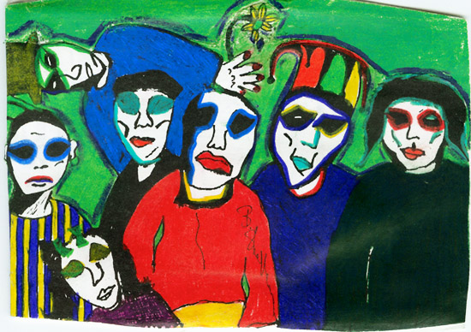
3. “When the bell rang again, when the door to the dock opened, what rose to meet me was the silence in the courtroom, silence and the strange feeling I had when I noticed that the young reporter had turned his eyes away. I didn’t look in Marie’s direction. I didn’t have tome to, because the presiding judge told me in bizarre language that I was to have my head cut off in a public square in the name of the French people. Then, it seemed to me that I suddenly knew what was on everybody’s face. It was a look of consideration, I’m sure” (106-107).

Chapter Five: Freedom and Death
4. “What really counted was the possibility of escape, a leap to freedom, out of the implacable ritual, a wild run for it that would give whatever chance for hope there was” (109).

5. “How had I not seen that there was nothing more important than an execution, and that when you come right down to it, it was the only thing a man could possibly truly be interested in?” (110).

6. “But everybody knows life isn’t worth living. Deep down I knew perfectly well that it doesn’t much matter whether you die at thirty or seventy, since in either case other men and women will naturally go on living—and for thousands of years. In fact, nothing could be clearer. Whether it was now or twenty years from now, I would still be the one dying” (114).

7. “For the first time, in that night alive with signs and stars, I opened myself to the gentle indifference of the world. Finding it so much like myself—so like a brother, really—I felt that I had been happy and that I was happy again. For everything to be consummated, for me to feel less alone, I had only to wish that there be a large crowd of spectators that day of my execution and that they greet me with cries of hate” (123).

