Albert Camus'
“The Guest”
Literary Analysis and Existentialism Quiz

Directions: On your own notebook paper, please answer each question thoroughly. For this quiz, you may use the book and your reading responses, but you may not share your book or reading responses with anyone else. Be sure to restate the question as part of your answer. Since some questions have more than one part, make sure you answer what is asked or only partial credit will be received. You must write in complete sentences.

1. Who is the protagonist and antagonist in the story? In addition, what type of main conflict does the protagonist face, and is it external or internal conflict?

2. In which country is the story set, and what event is happening in the country that has a direct affect on the protagonist’s situation?
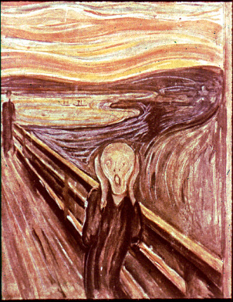
3. Clearly describe an event that unmistakably demonstrates the protagonist’s existential feeling of alienation and separation?

4. What event occurs for the Arab prisoner that clearly demonstrates Sartre’s assertion that an individual must make a choice in life and accept responsibility for that choice? Also, how is the Arab prisoner’s choice existential?

5. What is the resolution of the main conflict for the protagonist, and how does this represent a common theme of existentialism?

6. What is ironic that happens to the protagonist at the end of the story?

7. Clearly describe an event that unmistakably demonstrates the protagonist’s existential feeling of freedom?

8. Provide a clear example from the story that demonstrates the existential theme of how reason is impotent to deal with the depths of human life.

9. How does the protagonist’s conflict with the gendarme (French policeman) represent an existential theme? Be sure to clearly explain your answer.

10. Describe three instances where the protagonist demonstrates kindness toward the Arab prisoner, and explain how each represents an existential act.

