The Stranger

Point of View Quiz
Chapters 3, 4, 5, and 6

Directions: For each chapter, please write a response of at least one hundred and twenty five words. Be sure to write from the point of view asked in the writing prompt. Please use MLA format and your point of view rubric.

Chapter Three: Ways of Seeing
- Imagine you are Raymond and one of your hobbies is keeping a diary or journal of your day’s events. Reflect upon what’s happening to you in your relationship with your girlfriend and Meursault. Be sure to include the thoughts and feelings you have concerning them and their lives.

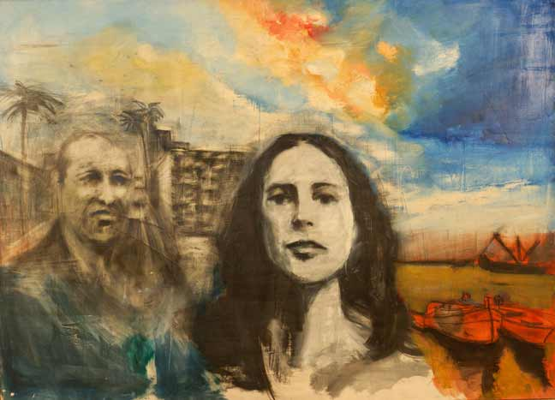
Chapter Four: People and Places
- Imagine you are Marie and you are writing a letter to your mother. In this letter, share with her what your day was like on Saturday, your concerns about Salamano, as well as what’s happening with Meursault.

Chapter Five: Shadows and Sounds
- Now you are Meursault who is writing a novel about his life. Imagine you are writing a chapter focusing on events that occurred during Chapter 5. Your focus will be on your thoughts, interactions, and feelings regarding Marie, eating at Celeste’s, and perspective of Salamano and how he perceives you.

Chapter Six: Ocean and Sun
- Time to get creative. You are a T.V. show producer who has a reality T.V. show called Existential Lives. In this episode, you have followed Meursault around Algiers and to the beach. Imagine you have to write an overview of the episode for your network bosses. This overview must be from an existential perspective. Analyze Meursault’s first encounter with the Arabs in town and Raymond’s conflict with them. Finally, provide an existential analysis of the sun’s affect on Meursault and what it ultimately lead him to do to one of the Arabs.

