The Stranger and The Truman Show Essay

Writing Situation: Individualism is a major aspect of American culture. While we tend to admire those whose individualism results in the achievement of the American Dream, we still expect those people to give something back to the community because we believe society helped shape these individuals to an extent and provided them with the environment in which to succeed. Existentialism, on the other hand, believes the individual needs to reject society and all of its essences in order to become a true individual, one who is free of all society’s trappings.

Directions for Writing: Choose one of the six topics below to write a multiparagraph essay based on the existential and archetypal aspects of Albert Camus’ The Stranger and Peter Weir’s The Truman Show. In your introduction, universally reflect upon the significance of the topic before tying it in to events in The Stranger and The Truman Show. Be sure your thesis statement is the last sentence of your introduction. In each body paragraph, use at least two examples from the book to prove your thesis. In addition cite at least two existential philosophers for additional support. Finally, restate the thesis in the conclusion and reflect upon the significance of your thesis as it relates to events in The Stranger and The Truman Show, as well as to the audience. Be sure to end your essay with an analogy or figure of speech that brings your essay to a powerful close that appeals to a general audience.

- Topic One: Write an essay using plot developments in The Stranger and The Truman Show to clearly compare and contrast how the themes of existential alienation and nothingness ultimately lead Meursault and Truman to existential freedom.

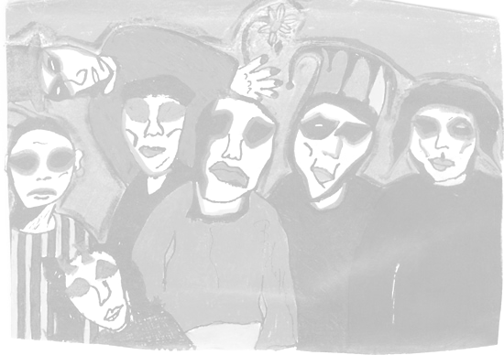
- Topic Two: Write an essay using plot developments in The Stranger and The Truman Show to compare and contrast how irony, existential themes, and archetypal symbols foreshadow Meursault and Truman’s ultimate fate.

- Topic Three: Write an essay using plot developments in The Stranger to clearly trace the evolution of Meursault’s existential philosophy. Explain how he eventually opens himself to “the gentle indifference of the world.” Be sure to analyze what created this insight, and how earlier existential events in the novel foreshadow his eventual death.

- Topic Four: Write an essay using plot developments in The Stranger to compare and contrast the relationship between Salamano and his dog with the relationship between Meursault and his mother by analyzing four existential themes. Be sure to analyze their similarities, as well as analyzing whether Salamano or Meursault is more loving.

- Topic Five: Write an essay using plot developments in The Stranger and The Truman Show to compare and contrast how the existentialism themes of existence preceding essence and absurdity lead Meursault and Truman to create meaning in otherwise meaningless lives.

- Topic Six: Write an essay using plot developments in The Stranger and The Truman Show by creating your own topic. Your topic must analyze events, existential themes, characterization, archetypes or other literary techniques in the plot and apply them to a clear subject on which to write. If you decide to create your own topic, you must first receive teacher approval before beginning to write.
The Stranger and The Truman Show Essay

Peer Evaluation and Written Comments. Using the rubric below, evaluate your The Stranger and The Truman Show essay. For this scale, a score of zero is lowest and a score of four is highest. After each criterion is evaluated, write in the margins of the rough draft a brief comment stating why that score was earned. Please be honest and conservative in evaluating the essay.

Introduction
- Introduction contains a universal lead that hooks your audience’s attention and meaningfully reflects about the topic you’ve chosen to write about 0 1 2 3 4 =
- Introduction narrows its reflective lead by smoothly transitioning into the topic for your essay, then sets the context of your topic by briefly summarizing The Stranger and The Truman Show in the context of your thesis 0 1 2 3 4 =
- Thesis statement is clear, argumentative, strongly controls your essay, thoroughly guides the direction of each body paragraph, and appears as the last sentence of the introduction 0 1 2 3 4 =

Body Paragraphs
- Each body paragraph contains a strong statement that is clearly based on the structure of your thesis and controls the paragraph in which it is written 0 1 2 3 4 =
- Each body paragraph analyzes in depth directly cited examples from The Stranger and The Truman Show to clearly support the structure of your thesis by analytically explaining (not summarizing) in several sentences or more how the cited examples prove your thesis 0 1 2 3 4 =
- At least one body paragraph contains an example of antithesis that is thoroughly refuted 0 1 2 3 4 =
Conclusion
- Conclusion clearly restates the thesis in different words, appears as the first sentence, and strongly states what was proved in the body paragraphs 0 1 2 3 4 =
- Reflects upon the dominant themes and issues for The Stranger and The Truman Show and its universal significance that were addressed in the introduction and proved in the body paragraphs 0 1 2 3 4 =
- Provides a strong, original final statement that uses a figure of speech to grab the audience’s attention
0 1 2 3 4 =

Throughout the Essay
- Written in MLA format, uses parenthetical citations, is at least five paragraphs long, contains paragraphs of at least twelve sentences or more whereby the writer varies the paragraph structure by providing in-depth, analytical, motivated, and on-topic writing 0 1 2 3 4 =
- Transitions and attribution smoothly connects sentences, direct citations, and or paragraphs 0 1 2 3 4 =
- Relatively free of pointers, spelling, grammatical, and mechanical errors 0 1 2 3 4 =

Add Scores and Total =
Divide Total by 12 = = =

Glossed and Word Processed Draft. Now that you’ve received your rubric score, revise your draft according to the rubric. After that revision, write your final draft and gloss the changes by highlighting them in each paragraph. Oh, and don’t forget to read the “Writers Rules,” “Pointers,” and “The Write Way” packet before doing your final draft, which, of course, must be typed and in MLA format.

