
Los Osos High School
~Where Excellence Is a Habit~

6001 Milliken Avenue, Rancho Cucamonga, California 91737 • (909) 477-6900 •FAX: (909) 460-5872

Chris Hollister, Principal
Susan Petrocelli, Assistant Principal
Josh Cho, Assistant Principal
Linda Hanford, Assistant Principal
Dody Jarrell, Assistant Principal

August 17, 2009
Dear Parent or Guardian:

In order to provide you with easy access to your daughter or son’s academic progress in my class, I have made my grade-book available to you on our class’s web page at www.mrjeffrey.com. To access your daughter or son’s progress in class, simply visit our web page, and click on the graphic of the graduate. To view the progress report, type in the last name of your daughter or son, and enter the password, which is her or his LOHS I.D. number (the shorter number on the school I.D. card, located beneath the bar code).

On the first or second day of each school week, my grade-book will be updated. While every attempt will be made to keep current, complete updates will occur every four-and-a- half weeks in order to correspond with the school’s progress reports and report cards; however, I do encourage you to visit it each week in order to get a profile of how your child is doing in class at any one moment. If you have any questions, please call me during school hours at (909) 477-6900, extension 2337 or e-mail me at mrj@mrjeffrey.com.

Sincerely,
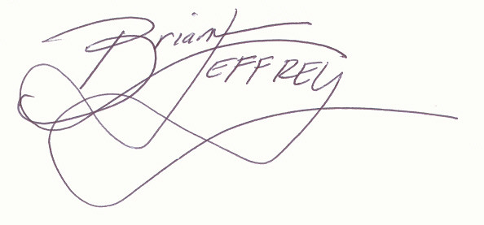

LOHS English Teacher

- Please fill in your daughter or son’s last name _____________, password ____________, and visit her or his progress report at www.mrjeffrey.com
(short I.D.)

- Currently, my daughter or son’s grade is a _____% and is missing _____ assignments.

Name of Daughter or Son Parent Signature Date

