Mr. Jeffrey American Mosaic
Los Osos High School Room C-37
Web Site: www.mrjeffrey.com E-Mail: mrj@mrjeffrey.com

Course Description

 American Mosaic is designed to educate students about the vibrant cultural diversity of the United States through readings in drama, poetry, fiction and non-fiction as well as the visual or audible realm of film, dance, art, and music. Course content will strengthen students’ reading, writing, listening, speaking and interactive skills and complements the California Language Arts Content Standards.

Student Expectations
☺  To develop critical thinking ability: We need to be able to distinguish between fact and fiction, between reality and demagoguery.

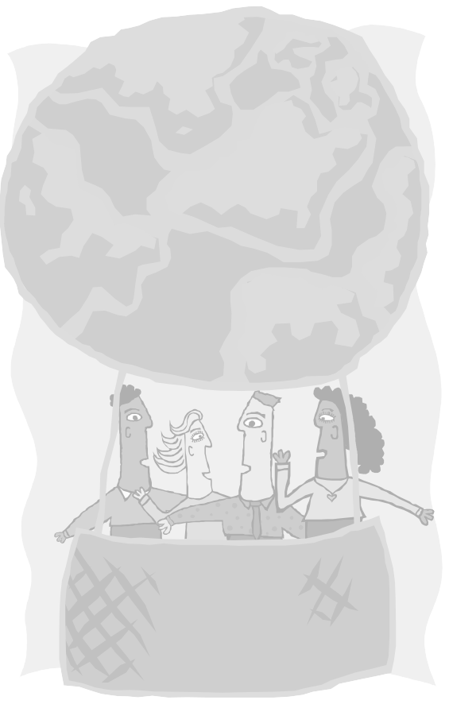
 To enhance self-esteem: We need to feel secure and comfortable about ourselves and about who we are. The more we know about ourselves, our culture and heritage, the stronger we become and the less likely we are to dislike others and see them as a threat.

☺ To counter stereotyping: we need to explore the many different experiences within the same cultural or religious groups. The best way to confront the stereotypes we all hold is to actively counter them by providing experiences that run opposite or counter to the stereotype.

 To build empathy: We need to connect our experiences with those that are different from ours. This can be accomplished effectively through the critical study of literature, videos, role-playing, television, music, art, dance, and interactive exercises.

☺ To encourage young people to takes steps to change the world: We need to be empowered to seek social justice. We need to provide opportunities for accomplishment to counter the debilitating affects of prejudice.

Class Rules Consequences
✓  Seated and ready to work when bell rings ✓ Friendly warning
✓  Respect ourselves and others ✓ Class suspension
✓  Zero putdowns ✓ Dropped from class

Attendance Policy
“Dropped from class on combination of fourth tardy and truancy”
 Absent? Call the Homework Hotline at 477-6900 - # 3430 

Classwork and Homework Policy

1. Assignments must have name, date, period, assignment number in 3. Classwork mandates participation
upper-right-hand corner, with title on title-line 4. Make-up work only for excused absences
2. LOHS plagiarism policy is strictly enforced (see Student Handbook) 5. All work turned in on time (no late work)

Expect homework one or two nights a week 

Participation grade weighted

Basis of Grading by your attendance

Authentic Assessment + Classwork/Homework = 75% Participation = 25% Absences Grade
Performance Activities Essays and Thematic Assignments Mosaic Notebook, 0 to 3 A
Group Projects Quizzes Note-Taking, Dis- 4 t0 6 B
Reading Summaries Journal Entries cussions, Attendance, 7 to 10 C
Blue Dot Assignments American Mosaic Notebook Attitude, Asking 11 to 15 D
Final Grade Sheet Questions 16 or more F

American Mosaic Notebook
Please obtain a one-and-a-half-inch, three-ring notebook (or use part of a larger notebook for another class) with 100 pages of lined paper with five page dividers arranged in the following order (due by January 28, 2006):
1. Assignments/Syllabus 2. Deep Thoughts 3. Cornell Notes
4. Back n’ Da’ Dayz 5. Reading Response

“Curriculum Highlights”

Title Author Genre Theme Week
“On the Pulse of Morning” Maya Angelou Poem Morning in America 1-2
“Saying Yes” Diana Chang Poem Becoming an American 2
Crash Paul Haggis Film Race in America 2-3 “Barrio Boy” Ernesto Galarza Short Story Struggle for Identity 3
Mi Familia Gregory Nava Film Becoming an American 3-4
“Where I Lived and What I Lived for” Henry David Thoreau Essay Struggle for Identity 5
Schindler’s List Steven Zaillian Film Struggle for Identity 5-8
“Letter from Birmingham Jail” Dr. Martin Luther King, Jr. Essay Voices of Freedom 9
The Autobiography of Malcolm X Malcolm X & Alex Haley Novel Excerpt Voices of Freedom 9
Malcolm X Spike Lee Film Voices of Freedom 9-11
Swing Era Music Various Song Preserving the Heritage 14
Mural Paintings Simon Silva & Frank Romero Art Preserving the Heritage 14
“In Response to Executive Order 9066” Dwight Okida Poem Rites of Passage 15
Farewell to Manzanar Jeanne Watkatsuki Houston Novel Excerpt Rites of Passage 15
Come See the Paradise Alan Parker Film Dreams and Ideals 15-17
Bowl of Beings Culture Clash Drama Dreams and Ideals 17-18

Textbook: Multicultural Perspectives (McDougall and Littell)

Progress Reports and Parent Contact

Progress reports will be issued every six weeks until the end of the eighteenth week when a semester grade will be issued. If a grade is a C minus or lower, then a Notice of Unsatisfactory Performance (NOUP) will be issued at four and a half-week intervals and contact will be made by phone or e-mail.

Please contact me if there are questions or concerns. During school, I can be reached at (909) 477-6900, ext. 2337. You may e-mail me at mrj@mrjeffrey.com and you can check on each day’s homework by going to our class web site at www.mrjeffrey.com or calling the homework hotline at (909) 477-6900-#3430. If your daughter or son needs tutoring, I am available at school from 3:00 P.M. until 4:00 P.M., or at your home (with a parent or guardian present) between 4:00 P.M. to 5:00 P.M., with one day’s advance notice.

Student and Parent Agreement
We have read and understand the course description, student expectations, class rules, attendance policy, homework policy, grading basis, American Mosaic notebook requirement, curriculum highlights, progress reports and parent contact policies, and accept them as stated.

 Student Name (Print Neatly)  Parent or Guardian Signature

