Checklist for Revision
Proofreading

- About them sentence fragments.

- Don’t use no double negatives.

- Try not to ever split infinitives.

- Read your essay out loud to yourself to avoid pointers and run-on sentences if you don’t you’ll have them.

- Verbs has to agree with their subjects.

- Between you and I, case is important.

- Let’s conversate about slang.

- Correct spelling is essentail.

- When dangling, watch your participles.

- Use your apostrophe’s correctly.

- Avoid clichés like the plague.

- Don’t use commas, that aren’t necessary.

- Proofread you writing.

- “Remember to provide attribution for a direct citation.”
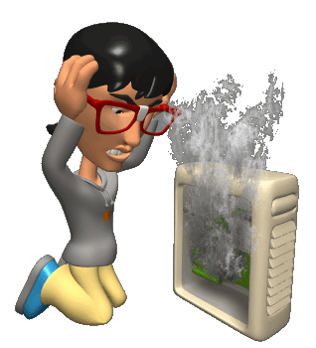

Symbol | Meaning | Example
 | Move Text | She wants to go also.
 | Delete | Quintisha is quite very happy.
 | No space | Inter net
 | Insert Period | See Jose download
 | Insert Comma | CD’s MP3, and camera.
 | Add Apostrophe | Kanye Wests world tour.
 | Add Quotations | On the Pulse of Morning
 | Transpose | To softly kiss
 | New Paragraph | dead. After the rave, she
 | Lower Case | the President
 | Capitalize | president  Obama
 | Spelling | Goerge Bush
 | Verb Tense | It was scary. It has one eye.
 | Subject/ Verb | The girls was here.
 | Add Space | website
 | Noun/Number Agreement | Everyone take out their book.
 | Incomplete Sentence | About those hotties.
 | Run-on Sentence | They went home they got caught.
 | Parenthetical Citation | (Thoreau, pg. 87).
 | Confusing: Revise | I spectator upon answers.
 | Pointer | Tran brought the stuff to class.
 | Transition and Attribution | …existential freedom. “Greet me with cries of hate” (Camus 116).
 | Longer Example | “Ignorance is strength” (Orwell 23).
 | More Explanation | Here, John Proctor represents those who were wrongly accused.

