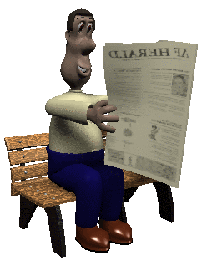

Parenthetical Citation

The lists of works cited at the end of your research paper plays an important role in the acknowledgment of sources, but it does not itself provide sufficient documentation. You must indicate exactly what you have derived from each source and exactly where in that work you found the material. The most practical way to supply this information is to insert brief parenthetical acknowledgments in your paper wherever you incorporate another's words, facts, or ideas. Usually, the author's last name and a page number are enough to identify the source.

Example: The longest word in the English language is a medical term "Pneumonoultramicroscopicsilico-volcanoconiosis is a miners' lung disease caused by the inhalation of silicate or quartz dust” (Lederer 39).

Note punctuation: period after the citation and of quotation mark

- If you have the same author for two or more sources, then put a comma after the last name of the author and add the title in as short a form as possible and then page number.

Example: English is a strange language. “Things that we say are underwater and underground are obviously surrounded by, not under, the water and the ground” (Lederer, Anguished 21).

The entire title of the book is Anguished English.

- If you use the author's name and title in the report itself, you need only put the page number in parenthesis.

Example: In Crazy English, Lederer wonders, "Why is it that when the sun moon or the stars are out, they are visible, but when the lights are out, they are invisible, and that when I wind up my watch, I start it, but when I wind up this essay, I shall end it?" (16).

Additional Formats

- If the list contains two authors with the same last name, then you’ll have to give the first initial as well.

- If two or three names begin the entry, give the last name of each person listed.

- If the work has more than three authors, give the first last author’s name followed by et al. Example: (Lederer et al).

Web Sites
- If you are citing a web site, follow the tips on the works cited page for the order of the information. Provide the first information that is available. If no author or page numbers are given, provide the name of the web page and the paragraph number (both in abbreviated form).

Example: Many other people have noted that English is a crazy Language. Where else can “we drive on a parkway and park on a driveway? What a strange language it is when our noses can run and our feet can smell" (Looking par. 7).

This example was from a website that had no author or page numbers. The name of the web page is “Looking at Language.” To find an author on a web page sometimes you really have to search the page.

