
Self-Conference

Questions about Information

Do I have enough information?
- How can I build on the strengths of this essay?
- Have I explained (shown, not told) by using strong examples?
- Have I described my thoughts and feelings fully?
- Have I shown where, when, with whom, and detailed the context of the event?
- Have I created good mind pictures for my audience?
- Is there a place where I could add more detail and explain more fully?
- Would direct citations, paraphrasing, or dialogue improve this essay?

Do I have too much information?
- What parts aren't needed and don't add to my thesis or essay?
- Can I delete them?
- Do I have more than one essay or story here?
- Which am I motivated to write?
- Is this a bed-to-bed essay, going through every event or topic?
- Can I focus on just one important part of it and delete the rest?
- Is there too much direct citation, paraphrasing, or dialogue?
- Are there too many fussy details (explaining or showing off topic)?

Questions about Leads

Does my lead grab my audience right away?
- Which kind of lead have I used?
  - Reflective? Descriptive? Action? Dialogue? Typical?
- Have I explained my lead in several sentences before tying in the subject?

Questions About Conclusions

Does my conclusion drop off and leave my audience wondering?
- Does my conclusion go on and on?
- How do I want my audience to feel at the end?
- Does this conclusion do it?
- What information do I want my reader to have at the end of the essay?
- Does this conclusion give that information?

Questions About Style
Am I striving to create my own voice as a writer?
- Have I overdone the descriptive words (showing not telling)?
- Have I said something more than once? Have I used any word(s) too often?
- Are any sentences too long and confusing? Too brief and choppy?
- Have I paragraphed often enough to give my audience's eyes some rest?
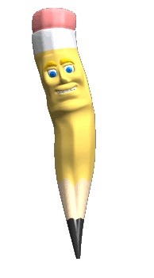
- Have I broken the flow of my essay by paragraphing too often?
- Is my information in order? Are the ideas developed in sequence?
- Have I grouped together ideas related to each other?
- Does the voice (tone) stay the same?
- Does the verb tense stay the same?

Questions about Titles
Does my title fit what the essay is about?
- Is my title a grabber?
- Would it make an audience want to read my essay?

