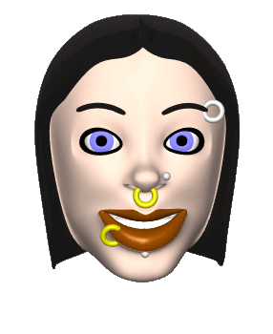
The Writing Process

What | How | Why
PREWRITE  Consider purpose and audience | Brainstorm, clustering, mapping, making a list, five W's & H, research, free-writing, interview | To gather information to decide on a topic;  to eliminate poor ideas; to focus on key points; to develop thesis statement
DEVELOP THESIS | Write a sentence that gives YOUR belief toward the topic | To focus your writing and state your objective as a writer
DECIDE ON SUPPORT | Pick out examples, details, statistics, case histories, proof, criticisms, etc. | To give credence to your ideas and proof for your thesis
DECIDE ON FORMAT | Decide on HOW to arrange information: chronological, spatial, order of importance, developmental order, comparison and contrast,etc. | To provide the reader with logical guides that will make your essay more enjoyable and easy to read
OUTLINE | Use scratch, formal or brainstorm outline. Depends on length, detail, and personal style | To help organize and balance information  and to "see" ideas
WRITE FIRST DRAFT | Use for working copy; organize ideas into paragraphs. Intro, body, and conclusion | To clear up "fuzziness"; improve examples, make corrections, change for effect; to improve introduction and conclusion, review vocabulary, syntax, spelling, grammar, structure
MINI-CONFERENCE | Meet with your teacher in a three to five minute meeting and read your draft out loud | To gain insight on how to develop you into a better writer
REVISE | Review with peers by reading essay out loud and receive a written evaluation | To gain suggestions from others and to have a "practice" audience
GLOSSING | Show the revisions and changes you’ve made by highlighting them | Allows the teacher to quickly see the revisions you’ve made to your first draft
FINAL DRAFT | Rewrite, using all suggestions that you think are appropriate | To present your best writing for evaluation
PUBLISHED DRAFT | Revise and rewrite after the teacher's evaluation | To have a quality draft for your portfolio

